Net GHG estimates using updated IPCC stock-change and flux-based methods for peatlands, wetlands and grasslands
Magnitude, duration and metric dependence applied to Ireland case study
Dr Seamus Murphy, ORCID-0000-0002-1792-0351, seamusrobertmurphy@gmail.com
Abstract
Background: The 2013 IPCC Wetlands Supplement replaced Equations 2.24 and 2.26 of the 2006 Guidelines, which had implicitly assumed that organic soils can only lose carbon, introducing the first negative Tier 1 emission factors in the guidelines’ history. Soil carbon gains in peatlands and coastal wetlands thereby became countable, and creditable in principle; the improved-grassland gain predates it. The pathways are scattered across two supplements and five chapters, their duration rules differ by more than an order of magnitude, and neither supplement weights a pathway’s carbon dioxide gain against its methane and nitrous oxide costs. Whether a countable gain is a climate benefit therefore cannot be determined from the guidance.
Results: We encode the default tables in base R and subtract the rewetted flux from its drained counterfactual across thirteen land use, climate and nutrient combinations. At GWP-100 the point estimate is positive in every combination, but Monte Carlo on the published 95% bounds puts the probability of benefit below 0.95 in five of thirteen and the median at or below zero in four. At GWP-20 the same five turn negative, all temperate or boreal: three Forest Land cases, nutrient-rich temperate Grassland, and temperate peat extraction. Beyond organic soils, a restored tidal marsh below 18 ppt is a net source in absolute terms while remaining a large benefit against its drained counterfactual; inland wetland mineral soil rewetting is a net source in all nine climate regions for twenty years and has no counterfactual in the guidance at all; and fertilised improved grassland crosses to a net source within decades, because a twenty-year gain meets a perpetual penalty. In Ireland’s reported inventory the same intervention is worth about seven t CO2e/ha/yr at GWP-100 and costs nearly three at GWP-20.
Conclusions: A countable carbon gain is not equivalent to a climate benefit. For a substantial minority of pathways the sign of the benefit is set by the emission metric and horizon rather than by the emission factor. Inventory compilers and crediting programmes should report the offsetting fluxes, the duration rule and the metric alongside any claimed soil carbon gain.

Introduction
The 2013 Supplement to the 2006 IPCC Guidelines, published in 2014, marks the point at which soil carbon gains became countable (IPCC, 2014). Its Chapter 3 states that Equation 3.1 replaces Equations 2.24 and 2.26 of the 2006 Guidelines, because those “implicitly assumed that organic soils can only lose carbon, while in fact undrained or rewetted organic soils can accumulate soil organic carbon if covered with vegetation”. These were the first negative Tier 1 emission factors in the history of the guidelines, and the first inventory-grade basis for claiming a soil carbon removal on a rewetted peatland, a replanted mangrove or an improved pasture.
A countable gain is not the same object as a climate benefit, and the guidance does not connect the two. Three properties of the corpus stand in the way. The gain pathways are distributed across two supplements and five chapters and have never been assembled on a single axis. Their duration rules differ by more than an order of magnitude: coastal wetland accumulation runs to a stock ceiling roughly two centuries distant, inland mineral wetland rewetting forty years, mineral soil management twenty, and organic soil rewetting applies from the year of rewetting with no transition period and no terminal date. And the Wetlands Supplement performs no greenhouse gas weighting anywhere in its 354 pages, so no document sets a pathway’s carbon dioxide gain against the methane and nitrous oxide it provokes.
A jurisdiction compiling an inventory, or a developer designing a project, therefore cannot determine from the guidance alone whether an intervention reduces radiative forcing. The arithmetic is absent by construction, because emission metrics are a policy choice the IPCC methodology reports declined to make and AR6 Box 7.3 declines to recommend (Forster et al., 2021).
Two studies bear directly on this. Wilson et al. (Wilson et al., 2016), written by the Supplement’s own authors, weight the drained and rewetted factors at GWP-100 and difference them, reporting large benefits for most land uses and a single negative case in temperate nutrient-rich Forest Land, for inland organic soils only and at that one metric. Zhang et al. (Zhang et al., 2025) tested metric sensitivity by Monte Carlo on United Kingdom peatlands, finding that the horizon turns one restoration step from a near-certainty into a 42.2% chance of increasing emissions under GWP-20 without reversing the headline; their GWP* implementation is adopted in Methods below. This paper extends both. We encode the Tier 1 and Tier 2 default tables directly, compute the drained-minus-rewetted benefit across every combination the Supplement supports, propagate the published bounds through Monte Carlo, repeat at a twenty-year horizon, add the duration dimension neither study considered, and place the remaining pathways on the same axis against their own non-carbon-dioxide offsets. The central finding is that for a substantial minority of pathways the sign of the benefit is set by the metric rather than by the emission factor, and that the metric test and the uncertainty test select the same rows.

1.1 Terminology
Two distinctions must be held throughout. Flux-based accounting, area multiplied by an annual emission factor, applies to organic soils only. Mineral soil is stock-change: Equation 2.25 differences two modelled equilibrium stocks and divides by a transition period, and there is no flux-based method for improved grassland. Separately, there is no reference stock (SOCref) for peat, because Batjes excluded organic soils by design (Batjes, 2011). That exclusion is why the two accounting logics coexist and must be reported separately rather than summed.

Methods
The IPCC reports removals as negative and emissions as positive. For legibility, gains here are reported as positive tonnes of carbon dioxide equivalent per hectare per year removed, and the sign is stated in every table caption.

2.1 Counterfactuals
A rewetted organic soil emits methane and is a net source in absolute terms in every climate zone and nutrient class. That is a property of wet peat, not a finding. The hypothesis concerns the intervention, so the quantity of interest is the difference between the rewetted state and the drained state it replaces:
$$\text{benefit}={\text{net flux}}_{\text{drained}}-{\text{net flux}}_{\text{rewetted}}$$
Reporting the absolute rewetted flux as a result would invert the published conclusion of Wilson et al. (Wilson et al., 2016) and contradict Günther et al. (Günther et al., 2020). The absolute fluxes appear below as model inputs and nowhere in Results.

2.2 Emission factors
Because the Supplement performs no weighting and AR6 recommends no single metric, results are reported under GWP-100 for comparability with inventory practice and under GWP-20 to expose the near-term methane penalty. Allen et al. (Allen et al., 2022), signed by both sides of the GWP* dispute, recommend reporting short-lived and long-lived gases separately rather than adjudicating between metrics, and we follow that position: the panel is a sensitivity, not a claim about which metric is correct. AR6 values are given in Table 1.Table 1
Table 1: AR6 Table 7.15 emission metrics used throughout. Biogenic methane is weighted at 27.0 at GWP-100, not at a value adjusted for the molar mass of carbon.
gas | gwp20 | gwp100 | gtp100
CH4_fossil | 82.5 | 29.8 | 7.5
CH4_nonfossil | 79.7 | 27.0 | 4.7
N2O | 273.0 | 273.0 | 233.0

2.3 Reference mineral soils
Table 2.3 of the 2019 Refinement supplies the reference stock SOCref, 0 to 30 cm, under native vegetation (IPCC, 2019), as arithmetic means from Batjes (Batjes, 2010, 2011). The forty-two cells encoded below span the Cool temperate, Warm temperate and Tropical zones; the Polar and Boreal rows are not encoded, and the consequence is set out in Limitations.

2.4 Emission factors for rewetted soils
Chapter 3 of the Wetlands Supplement applies from the year of rewetting with no transition period. Its factors are composite, covering soil and non-tree vegetation together, and are set out with their published bounds in Table 2.
Table 2: Model input: rewetted organic soils, t CO2e/ha/yr, positive = source. CO2 only is the countable soil carbon term; the net column adds DOC and methane. These are absolute fluxes, not benefits.
Zone | Nutrient status | n | CO2 only | Absolute net GWP-100
Boreal | Poor | 26 | -1.25 | 0.52
Boreal | Rich | 39 | -2.02 | 3.21
Temperate | Poor | 43 | -0.84 | 3.35
Temperate | Rich | 15 | 1.83 | 10.49
Tropical | All | 11 | 0.00 | 3.35

2.5 Emission factors for drained soils
The Supplement provides no nutrient-status split for temperate Forest Land in any of these four tables, although Equation 2.7 carries separate EF2_F,Temp,NR and EF2_F,Temp,NP terms and states that nutrient-poor and nutrient-rich organic soils drained for forestry have different nitrous oxide emissions. The equation and the table contradict each other. We assign the single temperate value to both nutrient classes and record it as an assumption rather than an IPCC default. That row is the empirical anchor for the only published case in which rewetting does not deliver a benefit, and the rewetted factor it is differenced against has intervals spanning zero on both carbon dioxide and methane.

2.6 Uncertainty propagation
Each factor is published as a central value with 95% bounds. Point estimates cannot support a claim about the sign of a net flux when those bounds straddle zero, so the benefit is resampled by Monte Carlo. Draws are triangular on the published central value and its bounds, defensible when only three numbers are available and the underlying distribution is not stated; the consequences are examined in Results.
Three terms are sampled: the carbon dioxide factor on the drained side, and the carbon dioxide and methane factors on the rewetted side. Drained land methane, drained ditch methane, Frac_ditch and the direct nitrous oxide factor carry no interval in Tables 2.3, 2.4 and 2.5 and enter at their defaults. The omission is not symmetric: it holds the drained side fixed in every term but one while the rewetted side varies in two, so the reported intervals understate total uncertainty and understate it unevenly.

2.7 Data sources
Two are global. The IPCC soil classification is a 5 arc-minute raster derived from the Harmonised World Soil Database, and it is crossed with the FAO Global Ecological Zones of 2010 to give area weights by climate zone and soil class, with cell area computed on the sphere so that it varies correctly with latitude. Because the ecological zones are built from vegetation while the IPCC climate zones are defined by temperature, precipitation and elevation, the crosswalk between them is an approximation, and the two mountain-system zones are ambiguous; both are documented in the analyses supporting scripts and a sensitivity reassigning the mountain zones to the dry side is reported alongside the main result. Pathway areas come from the Harmonised World Soil Database itself, 300,076 polygons, with Histosols mapped to the flux-based organic soil method and Gleysols to the Chapter 5 wetland mineral method. Only dominant soil components survived the source merge, so the mapped areas are a floor rather than an estimate.
Both global layers are shown over Ireland in Figure 1, because a stratification is easiest to audit against a country whose own soils are mapped independently. The exercise is worth doing before any national result is read. The ecological zone resolves cleanly: the Republic falls almost entirely in temperate oceanic forest, with a mountain-system inlier of 0.17 Mha, which places it in the cool temperate moist zone the reference stocks are keyed on. The soil classification does not resolve so cleanly, and the disagreement it exposes is quantified in Figure 5 against the national map.
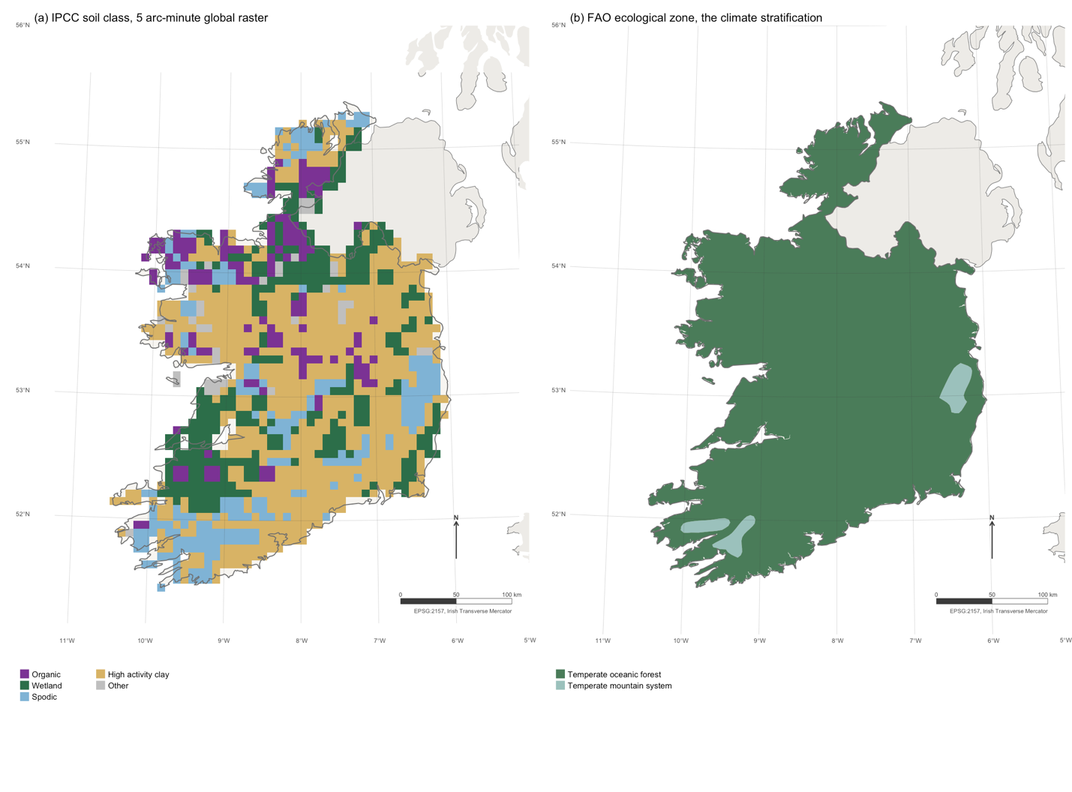
Figure 1: The two global layers that select which Tier 1 default applies, clipped to the Republic of Ireland. (a) The 5 arc-minute IPCC soil classification derived from the Harmonised World Soil Database. (b) FAO Global Ecological Zones 2010, the climate stratification. Graticule at one degree, EPSG:2157 Irish Transverse Mercator, north arrow and bar scale in the lower right of each panel.

Results

3.1 Benefits of rewetting
Subtracting the rewetted flux from its drained counterfactual gives the quantity the guidance never computes. The drained side applies Equation 2.6 in full, weighting land and ditch methane by Frac_ditch, which showed a GWP-100 benefit range of 1.26 to 54.54 across 13 rows and GWP-20 benefit range of -13.17 to 54.40.
Table 3: Benefit of rewetting, t CO2e/ha/yr. Positive means rewetting reduces net emissions. Drained includes CO2, DOC, land and ditch methane weighted by Equation 2.6, and direct nitrous oxide; rewetted includes CO2, DOC and methane, with nitrous oxide assumed negligible at Tier 1. Indirect nitrous oxide is omitted on the drained side, which understates the benefit.
Land use | Zone | Drain  status | Rewet match | n | Drain benefit | Rewet benefit | GWP-100 | GWP-20
Forest Land | Boreal | Poor | Poor | 59 | 1.78 | 0.52 | 1.26 | -0.97
Forest Land | Boreal | Rich | Rich | 62 | 5.42 | 3.21 | 2.21 | -7.03
Forest Land | Temperate | Unsplit | Rich | 8 | 12.08 | 10.49 | 1.59 | -13.17
Forest Land | Tropical | Unsplit | All | 21 | 24.82 | 3.35 | 21.47 | 21.22
Cropland | Temperate | Rich | Rich | 39 | 37.25 | 10.49 | 26.76 | 14.65
Cropland | Tropical | Unsplit | All | 10 | 57.89 | 3.35 | 54.54 | 54.40
Grassland | Boreal | Unsplit | Poor | 8 | 27.02 | 0.52 | 26.50 | 26.76
Grassland | Temperate | Poor | Poor | 7 | 24.03 | 3.35 | 20.68 | 17.38
Grassland | Temperate | Rich | Rich | 39 | 29.00 | 10.49 | 18.51 | 7.21
Grassland | Temperate | Rich | Rich | 13 | 16.73 | 10.49 | 6.24 | -5.59
Grassland | Tropical | Unsplit | All | NA | 41.76 | 3.35 | 38.41 | 38.27
Peat extraction | Temperate | Unsplit | Rich | 20 | 12.42 | 10.49 | 1.93 | -11.52
Plantation oil palm | Tropical | Unsplit | All | 10 | 45.07 | 3.35 | 41.72 | 41.23
At the published point estimates every complete combination in Table 3 shows a benefit at GWP-100, reproducing the qualitative conclusion of Wilson et al. (Wilson et al., 2016) and Günther et al. (Günther et al., 2020). The Monte Carlo qualifies that: four of the thirteen medians fall to or below zero once the published bounds are sampled. At GWP-20 five combinations turn negative, meaning rewetting those sites increases radiative forcing over twenty years. Every one is temperate or boreal, and every one is a case in which the drained carbon dioxide loss is modest while the rewetted methane flux is large. The tropical rows, where drainage releases five to twenty tonnes of carbon per hectare per year, are insensitive to the metric.Table 3
Wilson et al. (Wilson et al., 2016) report one negative case, temperate nutrient-rich Forest Land at −0.25 t CO2e/ha/yr. That row is encoded here and complete on all four gas terms. It does not reproduce as negative at GWP-100, but it is one of the five that turn negative at GWP-20. Two differences account for the gap. Wilson et al. weight methane at 34 and nitrous oxide at 298, values including climate-carbon feedbacks, against the AR6 values of 27.0 and 273 used here (Forster et al., 2021); and the single published temperate Forest Land value is assigned to both nutrient classes, as recorded in Methods. A disagreement between two studies about whether an intervention helps can therefore be entirely an artefact of the weighting each chose.
Table 4: Monte Carlo on the rewetting benefit, 10,000 triangular draws from the published 95% bounds, at GWP-100. Sampled terms are the CO2 factor on both sides and the methane factor on the rewetted side; drained land and ditch methane, the ditch fraction and nitrous oxide carry no published interval and are held at their defaults. P(benefit > 0) is the probability that rewetting reduces net emissions.
Land use | Zone | Nutrient | Median | P05 | P95 | P(benefit > 0)
Forest Land | Boreal | Poor | -0.45 | -4.54 | 2.38 | 0.421
Forest Land | Boreal | Rich | 0.00 | -7.46 | 5.10 | 0.500
Forest Land | Temperate | Unsplit | -2.53 | -15.73 | 6.67 | 0.357
Forest Land | Tropical | Unsplit | 19.04 | 5.26 | 30.66 | 0.997
Cropland | Temperate | Rich | 22.57 | 9.00 | 32.43 | 1.000
Cropland | Tropical | Unsplit | 57.85 | 36.20 | 85.52 | 1.000
Grassland | Boreal | Unsplit | 24.68 | 16.93 | 32.48 | 1.000
Grassland | Temperate | Poor | 17.76 | 9.98 | 24.05 | 1.000
Grassland | Temperate | Rich | 14.38 | 1.11 | 24.07 | 0.965
Grassland | Temperate | Rich | 1.73 | -11.69 | 11.99 | 0.586
Grassland | Tropical | Unsplit | 39.88 | 25.25 | 57.11 | 1.000
Peat extraction | Temperate | Unsplit | -2.98 | -16.56 | 7.02 | 0.336
Plantation oil palm | Tropical | Unsplit | 41.63 | 27.53 | 56.06 | 1.000

Table 5: Effect of treating the published central value as the mode of a triangular distribution on right-skewed bounds, rewetted organic soils, kg CH4-C/ha/yr.
Zone | Nutrient | Published CH4 | Sampled mean | Ratio
Boreal | Poor | 41 | 96.4 | 2.34
Boreal | Rich | 137 | 210.1 | 1.53
Temperate | Poor | 92 | 182.0 | 1.96
Temperate | Rich | 216 | 357.9 | 1.66
Tropical | All | 41 | 61.1 | 1.48

Table 6: Sensitivity of the headline count to the distributional assumption, out of thirteen rows, on identical published bounds.
Sampling distribution | Rows below P 0.95
Triangular w/ mode at published value | 5
Normal w/ mean at published value | 5
Uniform on published bounds | 6

Two properties of the sampler bear on how Table 4 should be read. The published value is passed as the mode of the triangular and the methane bounds are strongly right-skewed, so the sampled mean sits well above the published default (Table 5): 41 kg CH4-C/ha/yr becomes roughly 96 in boreal nutrient-poor, 92 becomes 182 in temperate nutrient-poor, and 216 becomes 358 in temperate nutrient-rich. That shift, rather than the width of the sampling, moves four medians to or below zero. Treating a 95% interval as hard support truncates both tails, which is why six rows print a probability of exactly 1.000; those should be read as above 0.999.Table 4Table 5
Neither property disturbs the headline (Table 6). Re-running the same bounds under a normal and under a uniform leaves the count of rows failing the 95% threshold at five and six of thirteen. The identity of the rows is robust to the distributional assumption even though the individual probabilities are not, and it is the count and the identity that the argument rests on.Table 6
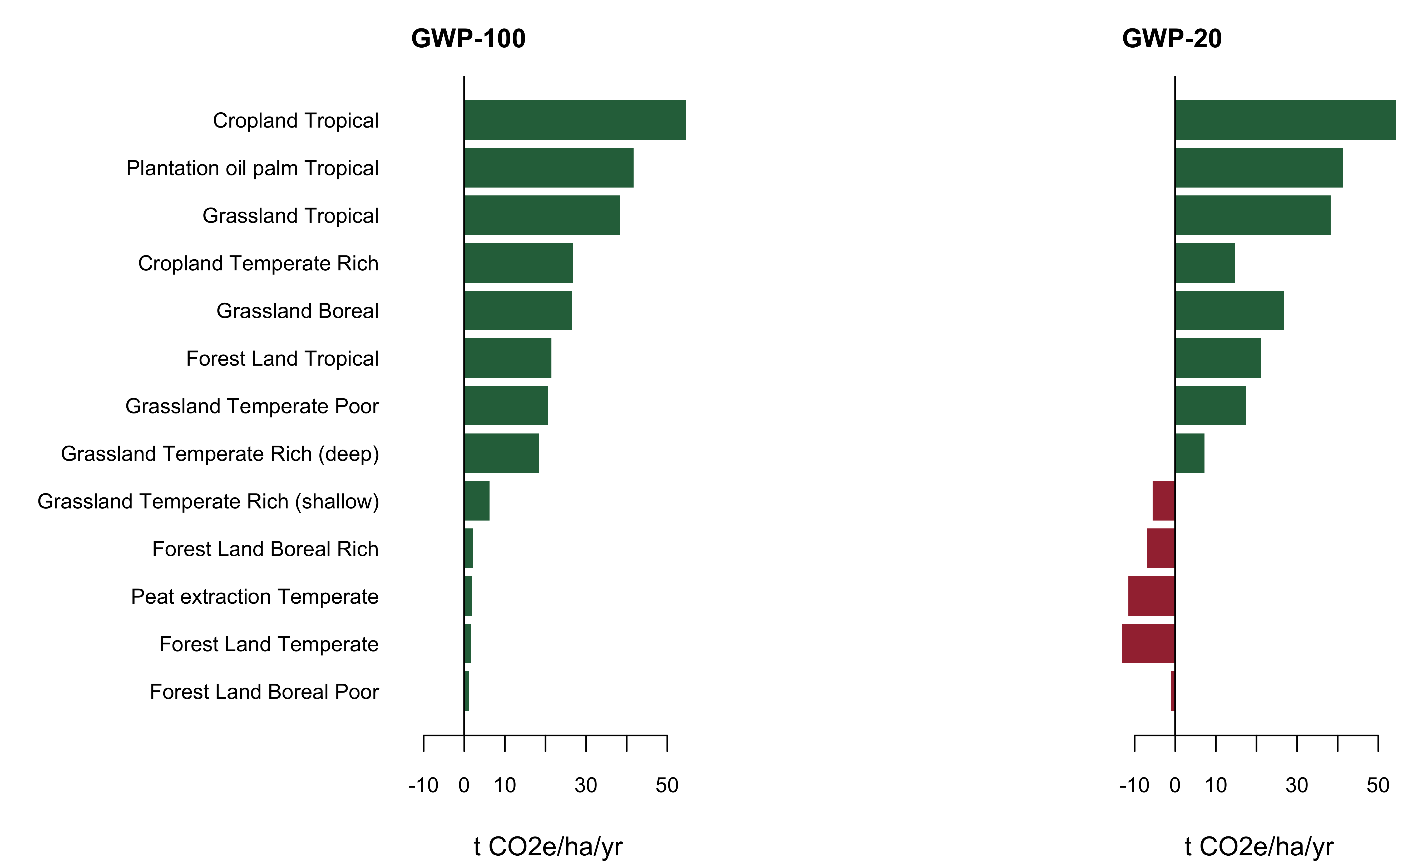
Figure 2: Benefit of rewetting by land use, climate and nutrient status, at two horizons. Bars left of zero are cases where rewetting increases radiative forcing. The GWP-20 panel is the same emission factors under a different weighting; nothing else changes between them.
The two tests select the same rows, as Figure 1 shows. Every combination that turns negative at GWP-20 also fails the 95% threshold at GWP-100, and none fails one test but passes the other. Both statistics are monotone in one quantity, the size of the benefit relative to the methane the rewetted state emits. The agreement is therefore not independent corroboration but the identity of the rows with no margin, and reporting only a GWP-100 point estimate, which is what inventory practice requires, conceals it either way.Figure 1

3.2 Coastal wetlands
Chapter 4 supplies the only factor in the corpus with no fixed end date other than a stock ceiling, applying “as long as the soil remains rewetted and vegetated”.
Table 7: Coastal wetland soil carbon, t CO2/ha/yr removed. Headroom depends on the stock present at rewetting; the bare-start column is an upper bound, not an expectation. Table 4.11 is titled for extraction activities and its column is the stock destroyed by excavation, not a documented accumulation ceiling. Salinity columns are NA for seagrass because Table 4.14 covers tidal marsh and mangrove only.
System | n | Soil gain | Headroom | at 25% stock | at 50% stock | Net >18 ppt | Net <18 ppt
Mangrove | 69 | 5.94 | 238 | 179 | 119 | 5.94 | 0.71
Tidal marsh | 66 | 3.34 | 280 | 210 | 140 | 3.34 | -1.89
Seagrass | 6 | 1.58 | NA | NA | NA | NA | NA

Table 8: Coastal wetlands with and without the counterfactual, t CO2e/ha/yr. The absolute columns are the restored state alone, positive = removal. The benefit columns subtract the restored state from the Table 4.13 drained counterfactual of 28.97 t CO2/ha/yr and are the quantity the hypothesis concerns.
System | Absolute >18 ppt | Absolute <18 ppt | Benefit >18 ppt | Benefit <18 ppt
Mangrove | 5.94 | 0.71 | 34.91 | 29.68
Tidal marsh | 3.34 | -1.89 | 32.31 | 27.08

The salinity gate is the decisive term for the absolute flux (Table 7). Below 18 ppt the single default of 193.7 kg CH4/ha/yr costs 5.23 t CO2e/ha/yr at GWP-100, exceeding the tidal marsh soil gain of 3.34, so on the Table 4.12 default a restored brackish tidal marsh is a net source in absolute terms, and the charge consumes most of the mangrove gain without extinguishing it. The sign is a property of that one default: the balance turns at about 1.43 t C/ha/yr, and the syntheses discussed below put tidal marsh accumulation on the other side of that threshold. What follows is the consequence of applying Tier 1 as published, not a claim that brackish marshes are sources.Table 7
It does not follow that restoring the marsh is harmful, and the counterfactual columns of Table 8 show why. Table 4.13 puts the drained state at 28.97 t CO2/ha/yr, so rewetting yields a benefit of about 27 t CO2e/ha/yr for tidal marsh and 30 for mangrove even under the freshwater methane penalty. The salinity gate flips the sign of the absolute flux and changes the benefit by less than a fifth. A restored wetland that emits methane is still a large improvement on the drained land it replaces.Table 8
What the gate determines is whether the pathway can be credited as a removal, since a scheme that books the absolute soil gain and charges the methane would find the balance negative. It is consequential for accounting and close to immaterial for the atmosphere. Two eligibility gates bind first: the site must be planted or seeded, because unassisted recolonisation scores zero, and canopy cover must reach 10%.

3.3 Inland wetlands
Chapter 5 supplies the only forty-year recovery in the guidance, as two consecutive twenty-year blocks, and the only stock-change gain in the Supplement.
Table 9: Inland wetland mineral soils, rewetting, t CO2e/ha/yr at GWP-100. Positive is a removal; the methane column is an emission and is subtracted. Table 5.3 sets two consecutive 20-year blocks, so the annual gain is not constant. Methane is the zone-matched Table 5.4 factor.
Zone | SOCref | Gain yr 1-20 | Gain yr 21-40 | CH4 offset | Net yr 1-20 | Net yr 21-40
Boreal | 116 | 1.91 | 4.25 | 2.05 | -0.14 | 2.20
Cold temp dry | 87 | 1.44 | 3.19 | 6.34 | -4.90 | -3.15
Cold temp moist | 128 | 2.11 | 4.69 | 6.34 | -4.23 | -1.65
Warm temp dry | 74 | 1.22 | 2.71 | 6.34 | -5.12 | -3.63
Warm temp moist | 135 | 2.23 | 4.95 | 6.34 | -4.11 | -1.39
Tropical dry | 22 | 0.36 | 0.81 | 24.30 | -23.94 | -23.49
Tropical moist | 68 | 1.12 | 2.49 | 24.30 | -23.18 | -21.81
Tropical wet | 49 | 0.81 | 1.80 | 24.30 | -23.49 | -22.50
Tropical montane | 82 | 1.35 | 3.01 | 24.30 | -22.95 | -21.29

This is the clearest case in the corpus of a countable gain that is not a benefit (Table 9). The stock-change term is positive and would be reported as a removal under Equation 5.1, yet the Table 5.4 methane factor exceeds it in every climate region Table 5.2 publishes during the first twenty-year block, and in all but the boreal region during the second. There is no drained counterfactual in Chapter 5, which says so in its own voice: “Due to the lack of studies, however, we are unable to develop guidance for CH4 emissions from drained IWMS at this time.” The comparison is therefore against the absolute flux, and the conclusion correspondingly weaker: the gain is smaller than its own offset, not worse than the alternative.Table 9
Three scope caveats apply. Table 5.3’s F_LU of 0.71 for long-term cultivated land is defined for temperate and boreal dry and moist regions only, yet is applied here to four tropical regions for want of a tropical value. Table 5.3 is a Cropland factor intended for use alongside management and input factors, set to unity here. And the boreal row, which carries the narrowest margin of the nine, rests on a single study with a 95% interval of plus or minus 76 on a mean of 76, so that region should be read as indistinguishable from zero.

3.4 Improved grasslands
Equation 2.25 run in the gain direction. F_LU is 1.0 for all grassland in all climates, so the compound factor is F_MG * F_I and the whole gain reduces to one coefficient (IPCC, 2019). Table 10 gives the resulting gain matrix.
Table 10: Improved grassland with high input. Gains in t CO2/ha/yr removed, accruing over 20 years and zero thereafter.
Climate zone | Soil | SOCref (t C/ha) | F after | Gain from nominal | Gain from degraded
Cool temp moist | HAC | 81 | 1.265 | 3.94 | 8.40
Cool temp moist | LAC | 76 | 1.265 | 3.70 | 7.88
Cool temp moist | VOL | 136 | 1.265 | 6.62 | 14.10
Cool temp moist | WET | 128 | 1.265 | 6.23 | 13.27
Cool temp dry | HAC | 43 | 1.265 | 2.09 | 4.46
Cool temp dry | LAC | 33 | 1.265 | 1.61 | 3.42
Cool temp dry | VOL | 20 | 1.265 | 0.97 | 2.07
Cool temp dry | WET | 87 | 1.265 | 4.23 | 9.02
Tropical montane | HAC | 51 | 1.288 | 2.69 | 5.49
Tropical montane | LAC | 44 | 1.288 | 2.32 | 4.74
Tropical montane | VOL | 96 | 1.288 | 5.06 | 10.34
Tropical montane | WET | 82 | 1.288 | 4.32 | 8.83
Tropical wet | HAC | 60 | 1.299 | 3.29 | 6.59
Tropical wet | LAC | 52 | 1.299 | 2.85 | 5.71
Tropical wet | VOL | 77 | 1.299 | 4.22 | 8.45
Tropical wet | WET | 49 | 1.299 | 2.68 | 5.38
Tropical moist | HAC | 40 | 1.299 | 2.19 | 4.39
Tropical moist | LAC | 38 | 1.299 | 2.08 | 4.17
Tropical moist | VOL | 70 | 1.299 | 3.83 | 7.68
Tropical moist | WET | 68 | 1.299 | 3.72 | 7.46
Tropical dry | HAC | 21 | 1.299 | 1.15 | 2.30
Tropical dry | LAC | 19 | 1.299 | 1.04 | 2.09
Tropical dry | VOL | 50 | 1.299 | 2.74 | 5.49
Tropical dry | WET | 22 | 1.299 | 1.20 | 2.41
Warm temp moist | HAC | 64 | 1.265 | 3.11 | 6.63
Warm temp moist | LAC | 55 | 1.265 | 2.68 | 5.70
Warm temp moist | VOL | 138 | 1.265 | 6.71 | 14.30
Warm temp moist | WET | 135 | 1.265 | 6.57 | 13.99
Warm temp dry | HAC | 24 | 1.265 | 1.17 | 2.49
Warm temp dry | LAC | 19 | 1.265 | 0.92 | 1.97
Warm temp dry | VOL | 84 | 1.265 | 4.09 | 8.71
Warm temp dry | WET | 74 | 1.265 | 3.60 | 7.67

3.5 The nitrogen trap
Table 6.2 lists fertilisation as a qualifying improvement. Fertilisation triggers nitrous oxide, which is annual and open-ended, while the soil carbon gain is capped at D years by Equation 2.25.
Table 11: Break-even nitrogen rate and crossover year. Beyond the crossover year the fertilised grassland is a net source in CO2e terms.
# | gain_tCO2_ha_yr | breakeven_kgN | crossover_yr_at_100N | crossover_yr_at_200N
low | 0.92 | 156 | 31 | 0
mid | 2.98 | 506 | 101 | 51
high | 6.71 | 1138 | 228 | 114

Because the carbon gain is finite and the nitrous oxide is perpetual (Table 11), every fertilised improved grassland crosses to a net source eventually. The only question is whether the crossover falls inside the accounting horizon. The structure is the same one Lugato et al. (Lugato et al., 2018) identified for nitrogen-fixing cover crops, where roughly half of modelled sites became net greenhouse gas sources by 2060, and Li et al. (Li et al., 2005) found that nitrous oxide offsets 75 to 310% of sequestered carbon in cropland over twenty years.
There is an escape. Fertilisation is only one of the qualifying improvements. Species improvement combined with grazing management earns the same F_MG factor with no nitrogen penalty at all, and biological nitrogen fixation is not a direct nitrous oxide source under the Guidelines, having been removed “because of the lack of evidence of significant emissions arising from the fixation process itself”. The grassland chapter that awards the gain contains no occurrence of nitrous oxide in its twenty-one pages, while the nitrous oxide methodology sits in Chapter 11 of the same volume. That is how a pathway can carry a trap that neither chapter is responsible for closing.

3.6 Reference stocks bias
Every mineral soil gain above scales linearly with SOCref. Table 2.3 publishes arithmetic means, while Batjes also published medians with median absolute deviation (Batjes, 2010). For skewed distributions the median is the robust statistic, so the published defaults sit above the robust central estimate.
Table 12: Ten most biased Table 2.3 cells. bias_pct is the percentage by which the published mean exceeds the robust median. cv_pct is the dispersion of the underlying profiles; stated_err_pct is the precision of the mean, which is what Table 2.3 reports.
zone | soil | n | mean | median | bias_pct | cv_pct | stated_err_pct
W2 | VOL | 10 | 84 | 33 | 154.5 | 104.8 | 64.9
W1 | WET | 28 | 135 | 94 | 43.6 | 74.8 | 27.7
T1 | WET | 12 | 82 | 58 | 41.4 | 89.0 | 50.4
T1 | VOL | 10 | 96 | 74 | 29.7 | 50.0 | 31.0
T3 | WET | 55 | 68 | 53 | 28.3 | 66.2 | 17.5
W2 | HAC | 781 | 24 | 19 | 26.3 | 66.7 | 4.7
W1 | SAN | 39 | 36 | 29 | 24.1 | 72.2 | 22.7
T4 | HAC | 554 | 21 | 17 | 23.5 | 61.9 | 5.2
T1 | LAC | 84 | 44 | 36 | 22.2 | 50.0 | 10.7
C1 | SAN | 126 | 51 | 42 | 21.4 | 76.5 | 13.4

Per-cell figures (Table 12) treat a cell covering half a continent and one covering a few hundred thousand hectares as equally important. Weighting by the land each combination occupies asks whether a compiler applying Table 2.3 to a real landscape meets the bias often or rarely.Table 12
Table 13: The eight largest climate-by-soil combinations by mapped global area, with the percentage by which the Table 2.3 published mean exceeds the robust median. FAO ecological zones are used as a proxy for the IPCC climate zones, which are defined climatically rather than ecologically.
Zone | Soil | Area (Mha) | Bias (%) | Profiles
T4 | HAC | 1752.3 | 23.5 | 554
C1 | HAC | 1124.2 | 9.5 | 334
C2 | HAC | 953.4 | 13.2 | 177
W2 | HAC | 953.4 | 26.3 | 781
T2 | LAC | 945.9 | 13.0 | 271
W1 | HAC | 668.9 | 8.5 | 489
T3 | LAC | 599.9 | 15.2 | 326
T4 | SAN | 500.7 | 12.5 | 164

The weighting neither rescues the defaults nor condemns them (Table 13). Area weighting pulls the mean bias from 18.6% to 15.5%, and reassigning the ambiguous mountain zones moves it by one percentage point, but the figure still sits above the unweighted median of 13.0%. The bias is not an artefact of a few small cells; it is spread across the combinations carrying most of the world’s mineral soil.Table 13
Three caveats bound this. The crosswalk from FAO ecological zones to IPCC climate zones is an approximation, since the first is built from vegetation and the second from temperature, precipitation and elevation, which is why the sensitivity run is included. Roughly a fifth of classified land falls in Boreal and Polar zones the encoded table does not cover, and around 265 Mha of organic soil is excluded by construction: the reference-stock logic has nothing to say about peat.
The distinction in the last two columns is the substantive point. The error published in Table 2.3 is the precision of a global mean and narrows with sample size. It is not a statement about how much soils vary at a given site, and it is roughly four times too small to be read that way. A compiler propagating it through Equation 2.25 reports the certainty of a global average, not the uncertainty of the parcel being credited.

3.7 The assembled ledger
The ledger, Table 14 and Figure 2, makes the asymmetry visible. The pathway with the largest annual gain is not the one with the largest lifetime gain, because the duration rules are not commensurate. A mangrove earning 5.94 t CO2/ha/yr to a stock ceiling two centuries away and an improved grassland earning a comparable annual figure for exactly twenty years are not the same asset, yet nothing requires the duration rule to be reported alongside the factor.
Table 14: The countable gain ledger. Gains are maxima across climate and soil class; see the preceding sections for the full matrices.
Pathway | Source | Max gain  (tCO₂ ha/yr) | Duration | Eligibility gate | Offset
Mangrove rewet | WS Tb 4.12 | 5.94 | To stock ceiling | Planted or seeded; >=10% canopy | CH4 if <18 ppt
Tidal marsh rewet | WS Tb 4.12 | 3.34 | To stock ceiling | Planted or seeded; >=10% canopy | CH4 if <18 ppt
Seagrass restored | WS Tb 4.12 | 1.58 | To stock ceiling | Planted or seeded | CH4 if <18 ppt
Rewet organic nutrient-rich | WS Tb 3.1 | 2.02 | From yr 1 inf. | Nutrient status | CH4 + DOC
Rewet organic nutrient-poor | WS Tb 3.1 | 1.25 | From yr 1-40 | Nutrient status | CH4 + DOC
Inland rewet wetland | WS Tb 5.3 | 4.95 | 40yr | None | CH4
Improved grassland input+ | 2019 Tb 6.2 | 6.71 | 20 years | Improvement applied | N2O if fertilised
Improved grassland input++ | 2019 Tb 6.2 | 14.30 | 20 years | Improvement applied | N2O if fertilised
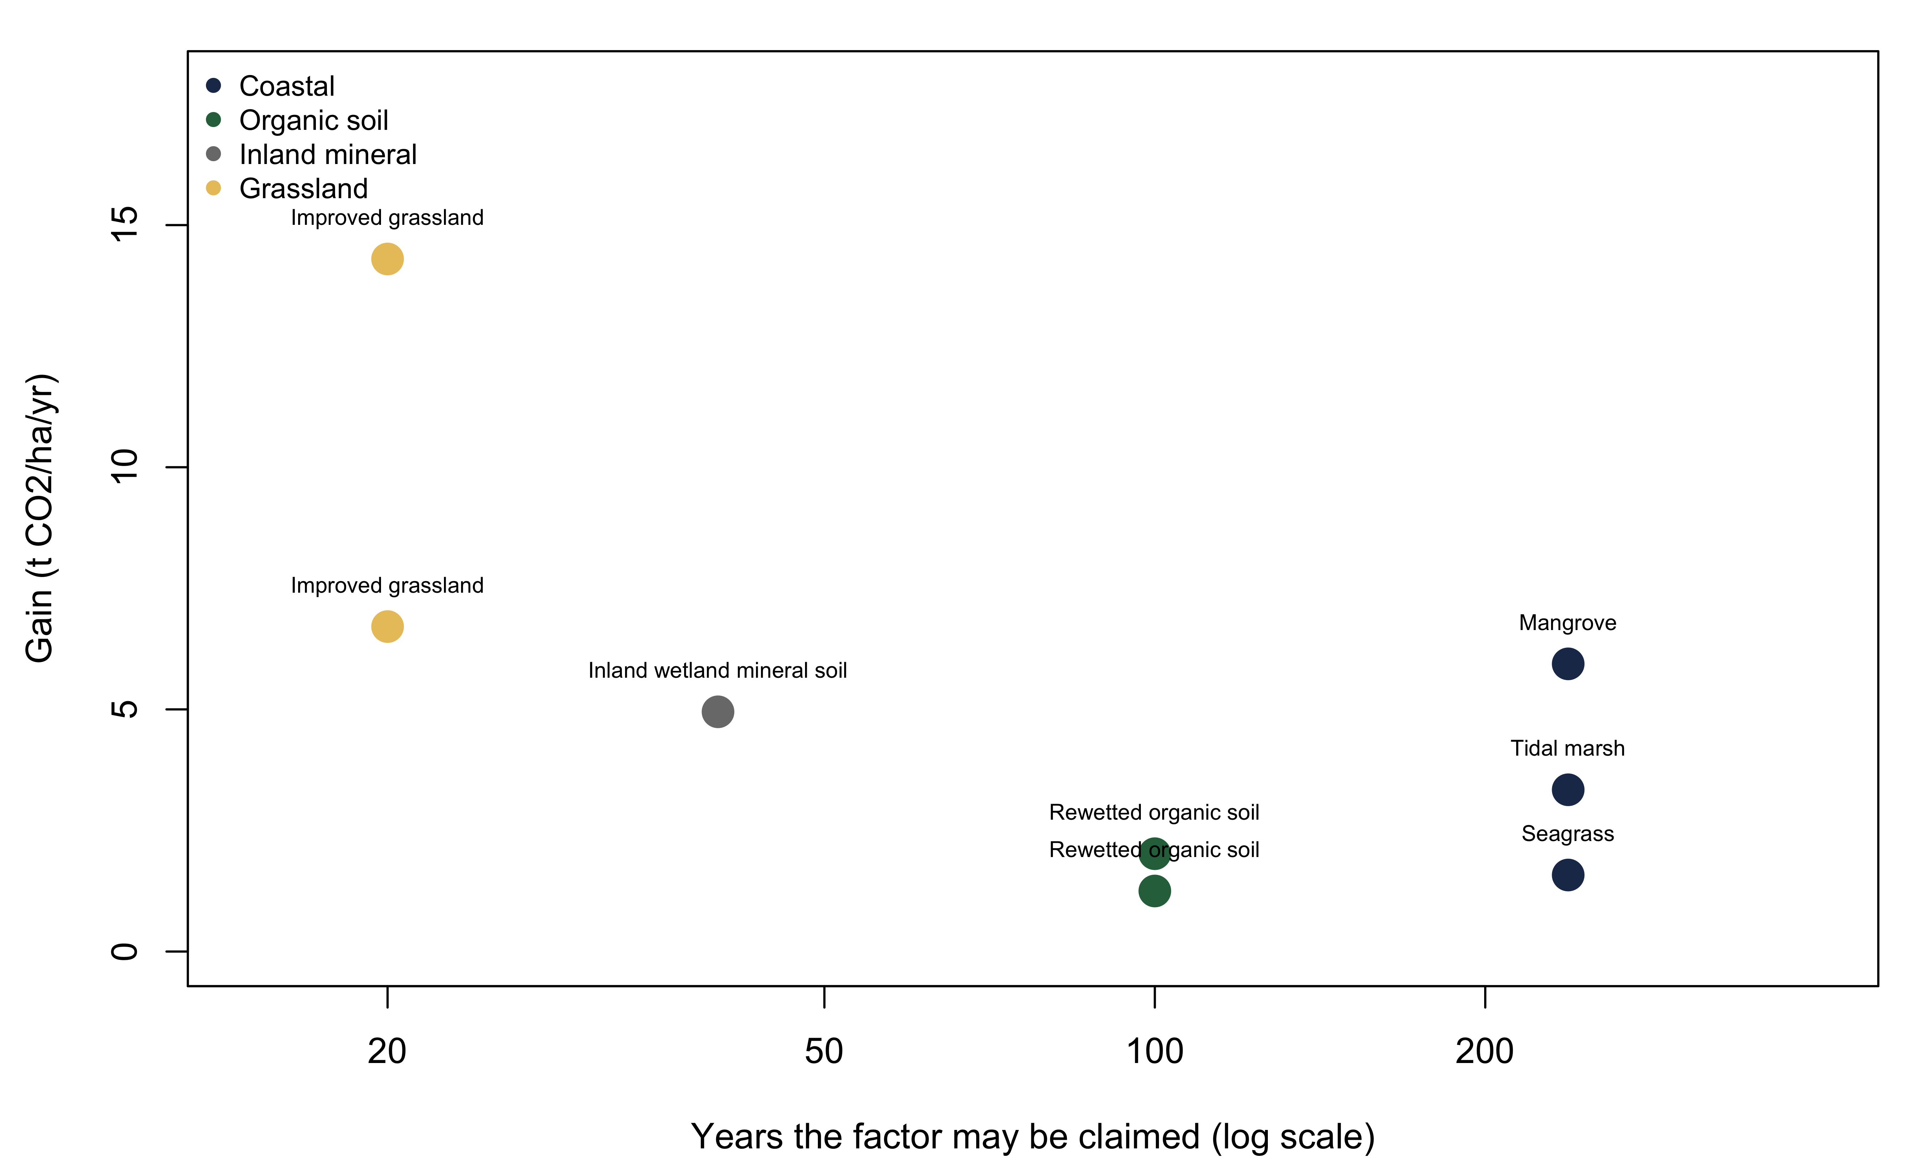
Figure 3: Annual gain against the years over which it may be claimed. The horizontal axis is logarithmic because the duration rules span more than an order of magnitude. Two pathways with the same annual factor are not the same asset if one runs for twenty years and the other to a stock ceiling two centuries away.
Everything above is a rate, and Figure 4 shows the estate those rates apply to. A rate says what a hectare earns and for how long; it does not say whether the pathways are collectively worth a hundred megatonnes or ten gigatonnes. Multiplying by area is the step that turns a ledger of factors into a statement about the atmosphere, and it is the step the guidance never asks anyone to take.
Every total below is a rate multiplied by an area, and it inherits every weakness of both. The rates carry the metric dependence and the sampling uncertainty established above. The areas carry a peatland undercount of unknown size, an unresolvable drained fraction, and for grassland a denominator that is a proxy rather than a measurement. These figures are reported to set scale, not to be cited as estimates of the global carbon flux from these pathways. The paper’s findings are the per-hectare results and their sign behaviour, which rest on encoded defaults and a counterfactual. A global total is the least defensible number in this manuscript and is presented as such.
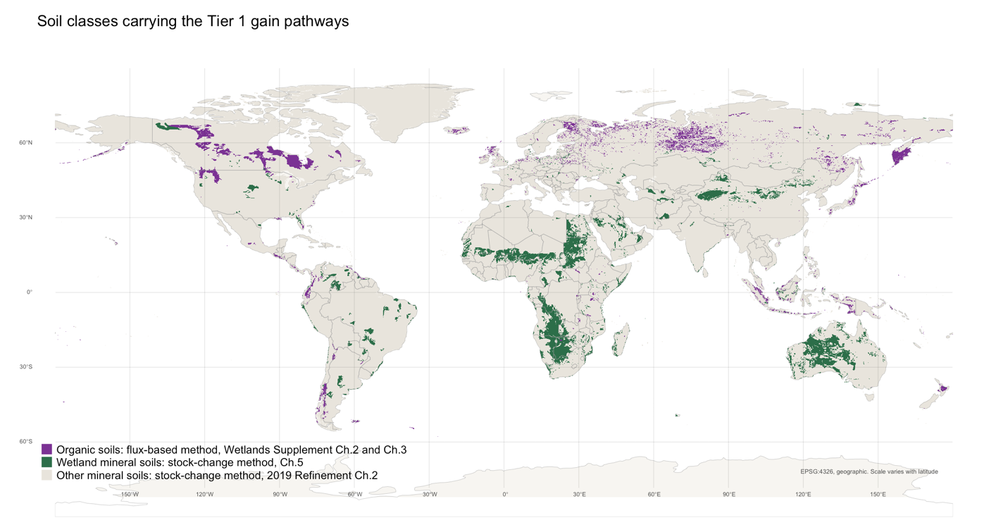
Figure 4: The soil estate the Tier 1 gain pathways apply to, from the 5 arc-minute IPCC soil classification. Organic soils carry the flux-based method of Wetlands Supplement Chapters 2 and 3; wetland mineral soils carry the Chapter 5 stock-change method; all other mineral soils fall under the 2019 Refinement Chapter 2 reference stocks. The two colored classes are the estate this paper’s ledger covers, and the boundary between them is the boundary between the corpus’s two accounting logics.
That estate is drawn from a global default layer, and a global default layer can be tested wherever a country has mapped its own soils. Ireland is such a country, and Figure 5 sets the two against each other at the same scale. The 5 arc-minute classification finds 0.71 Mha of organic soil in the Republic; the national soils map carries 1.90 Mha of peat, and the difference is not noise but structure. The default recovers the north-western blanket bog and almost nothing else, missing the western seaboard and most of the midland raised bogs, because a cell of roughly fifty square kilometres cannot hold a bog of two. The direction of the error is the one that matters: the coarse layer undercounts by nearly two thirds precisely where the flux-based method carries the largest factors. Every global area in this section should be read as a floor for that reason as well as for the merge described above, and the Irish ratio is offered as one country’s calibration of how much of a floor, not as a correction to be applied elsewhere.

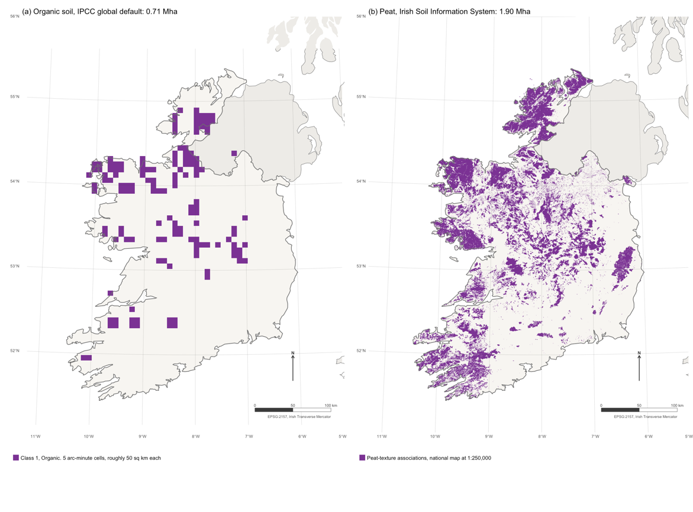
Figure 5: Organic soil as the global default has it, against the national map, at one scale. (a) Cells classified organic in the 5 arc-minute IPCC soil classification, the same layer underlying Figure 4 and the area weights. (b) Peat-texture associations in the Irish Soil Information System, 1:250,000. Areas are computed from the geometry in EPSG:2157, not read from a stated hectares column.
Three qualifications follow, on the organic soil totals of Table 15 and the two pathways of Table 16 whose eligible area cannot be derived from soil class. Rewetting all mapped organic soil would be worth roughly the total above at GWP-100 and substantially less at GWP-20, but the figure assumes every hectare is drained and then rewetted, which no jurisdiction proposes, and the mapped area is a floor; the honest reading is an order of magnitude. No global total is reported for the wetland mineral pathway, because Chapter 5 applies to cultivated wetland mineral soil and no global layer resolves the cultivated fraction of Gleysols. And the grassland figure is an upper bound on an upper bound: ecological zones are potential vegetation rather than managed pasture, and no nitrous oxide is charged because the applied nitrogen rate is unknown globally.
Table 15: Organic soil rewetting, Mt CO2e/yr. Benefit columns are t CO2e/ha/yr averaged over the land uses in each zone. The total columns are an upper bound on the opportunity, not a projection: they assume every mapped hectare is drained and then rewetted.
Zone | Area (Mha) | Benefit  GWP-100 | Benefit  GWP-20 | Drain-rewet  GWP-100 | Drain-rewet  GWP-20 | 10% drained, GWP-100
Boreal | 103.9 | 9.99 | 6.25 | 1038.0 | 649.4 | 103.8
Temp | 22.4 | 12.62 | 1.49 | 282.7 | 33.4 | 28.3
Tropical | 5.0 | 39.03 | 38.78 | 195.2 | 193.9 | 19.5

Table 16: The two pathways whose eligible area cannot be derived from soil class. No total at 100% is given: Chapter 5 applies only to cultivated wetland mineral soil being rewetted, and the grassland denominator is ecological zone rather than managed pasture. The columns show what the rate implies at illustrative eligible fractions, which is the most that can honestly be said.
Pool & activity pathway | Area (Mha) | t CO2e ha/yr | Mt CO2e/yr at 5% eligible | Mt CO2e/yr at 10% eligible | Mt CO2e/yr at 25% eligible
Peatland rewetting | 398 | -12.45 | -248 | -496 | -1239
Improved grassland | 1830 | 1.30 | 119 | 238 | 595

3.8 Ireland: national case study
Ireland is a useful test because it has done what the guidance does not require: it derived country-specific Tier 2 factors for organic soils from a national flux compilation (Aitova et al., 2023) and adopted them into its inventory. Where a national value exists the paper’s question can be asked twice, once with the IPCC default and once with the measured factor.
Table 17: Irish country-specific factors against the Wetlands Supplement temperate defaults, after Aitova et al. (2023) Table 2. CO2 in t C/ha/yr, CH4 in kg CH4-C/ha/yr. A ratio below 1 means the Irish measurement is lower than the default.
Land use | Nutrient | CO2 Tier 1 | CO2 Irish | Ratio | CH4 Tier 1 | CH4 Irish | Ratio
Grassland | Poor | 5.30 | 1.30 | 0.25 | 1.4 | 8.82 | 6.30
Grassland deep-drained | Rich | 6.10 | 5.08 | 0.83 | 12.0 | -0.75 | -0.06
Industrial cutaway | Poor | 2.80 | 1.21 | 0.43 | 4.6 | 0.00 | 0.00
Industrial cutaway | Rich | 2.80 | 2.18 | 0.78 | 4.6 | -0.30 | -0.07
Domestic cutover | Poor | 2.80 | 1.59 | 0.57 | 4.6 | 4.60 | 1.00
Forestry | Poor | 2.60 | 1.68 | 0.65 | 1.9 | NA | NA
Near-natural | Poor | -0.23 | -0.33 | 1.43 | 92.0 | 54.70 | 0.59
Rewetted extraction | Poor | -0.23 | -0.23 | 1.00 | 92.0 | 79.80 | 0.87
Rewetted grassland | Poor | -0.23 | 0.85 | -3.70 | 92.0 | 68.10 | 0.74
Rewetted extraction | Rich | 0.50 | 3.22 | 6.44 | 216.0 | 117.90 | 0.55

Nutrient-poor drained grassland is the diagnostic cell of Table 17. Its carbon dioxide factor is roughly four times below the default while its methane factor is more than six times above it, on the same hectares of the same land use. A single default cannot be conservative for both gases at once, and widening the confidence interval does not repair it, because the two errors point in opposite directions. The Supplement offers no cell to fall back on: Tables 2.1, 2.3 and 2.5 sub-split deep from shallow drainage only within nutrient-rich temperate grassland, and there is no entry for shallow-drained nutrient-poor temperate grassland, the modal Irish case.Table 17
The strongest test uses only what Ireland reports to the UNFCCC. Ireland splits the balance for a hectare of organic soil across two tables: Table 4.D carries the on-site soil carbon stock change, Table 4(II) the off-site carbon dioxide, nitrous oxide and methane. Neither is the balance. Adding them is the arithmetic the guidance does not require.
Table 18: Industrial peat extraction in Ireland, 2024, t CO2e/ha/yr, positive = net source. Built entirely from Ireland’s reported implied emission factors: on-site soil carbon from Table 4.D plus off-site CO2, N2O and CH4 from Table 4(II).
Metric | Drained | Rewetted | Benefit of rewetting
AR5 GWP-100 | 15.02 | 8.19 | 6.83
AR6 GWP-100 | 15.00 | 7.98 | 7.02
AR6 GWP-20 | 16.19 | 19.08 | -2.89

The sign flips with the horizon, inside a live national inventory (Table 18). Rewetting Irish industrial peat extraction is worth roughly seven tonnes of carbon dioxide equivalent per hectare per year at GWP-100 and costs nearly three at GWP-20. The driver is a rewetted methane implied factor around nine times the drained one, which a hundred-year weighting discounts and a twenty-year weighting does not. Ireland reports at AR5 GWP-100, and no short-lived-pollutant treatment appears anywhere in its land-use reporting.Table 18
One boundary difference is the likeliest source of disagreement with any factor-based Irish estimate. The figures here are the full reported balance, on-site plus off-site. A comparison built from on-site fluxes alone excludes terms large enough to move the sign on their own, so whether a national pathway helps or harms can turn on where the inventory boundary is drawn, before any question of metric arises.
The near-natural row makes the same point without any intervention. Ireland books 885,000 hectares of near-natural peatland as a soil carbon removal, and it is one. Adding the dissolved organic carbon and methane Ireland reports for the same hectares turns it into a net source of about 1.5 t CO2e/ha/yr, roughly 1.3 Mt nationally. The reference condition of restoration does not net out its own methane.

3.9 National saltmarsh data
The coastal result turns on a single threshold, and no dataset joins Irish marsh extent to salinity. Both layers are public, so we build the join.
Table 19: Confirmed Annex I saltmarsh in Ireland by the salinity regime of the transitional water body containing it. Salinity is water-column, measured at low-tide seine stations in 2015, not marsh porewater.
Salinity class | Area (ha) | % | Polygons
Not surveyed | 1149.6 | 50.7 | 1470
Unclassed water body | 893.3 | 39.4 | 3983
Spans 18 ppt | 225.1 | 9.9 | 614

Two results in Table 19 and Figure 4, and the second is the larger. About a tenth of Ireland’s confirmed Annex I saltmarsh sits in estuaries recorded below 18 ppt at some point in a single 2015 survey, and on those hectares the Table 4.14 default costs more than the soil gain is worth. Not one hectare falls in a water body measured to stay above the threshold throughout.
Ninety per cent cannot be classified at all: half sits in transitional water bodies where salinity has never been measured, and two fifths outside the transitional network. A gate that determines the sign of a national pathway is unresolvable for nine tenths of the resource using the data the State collects.
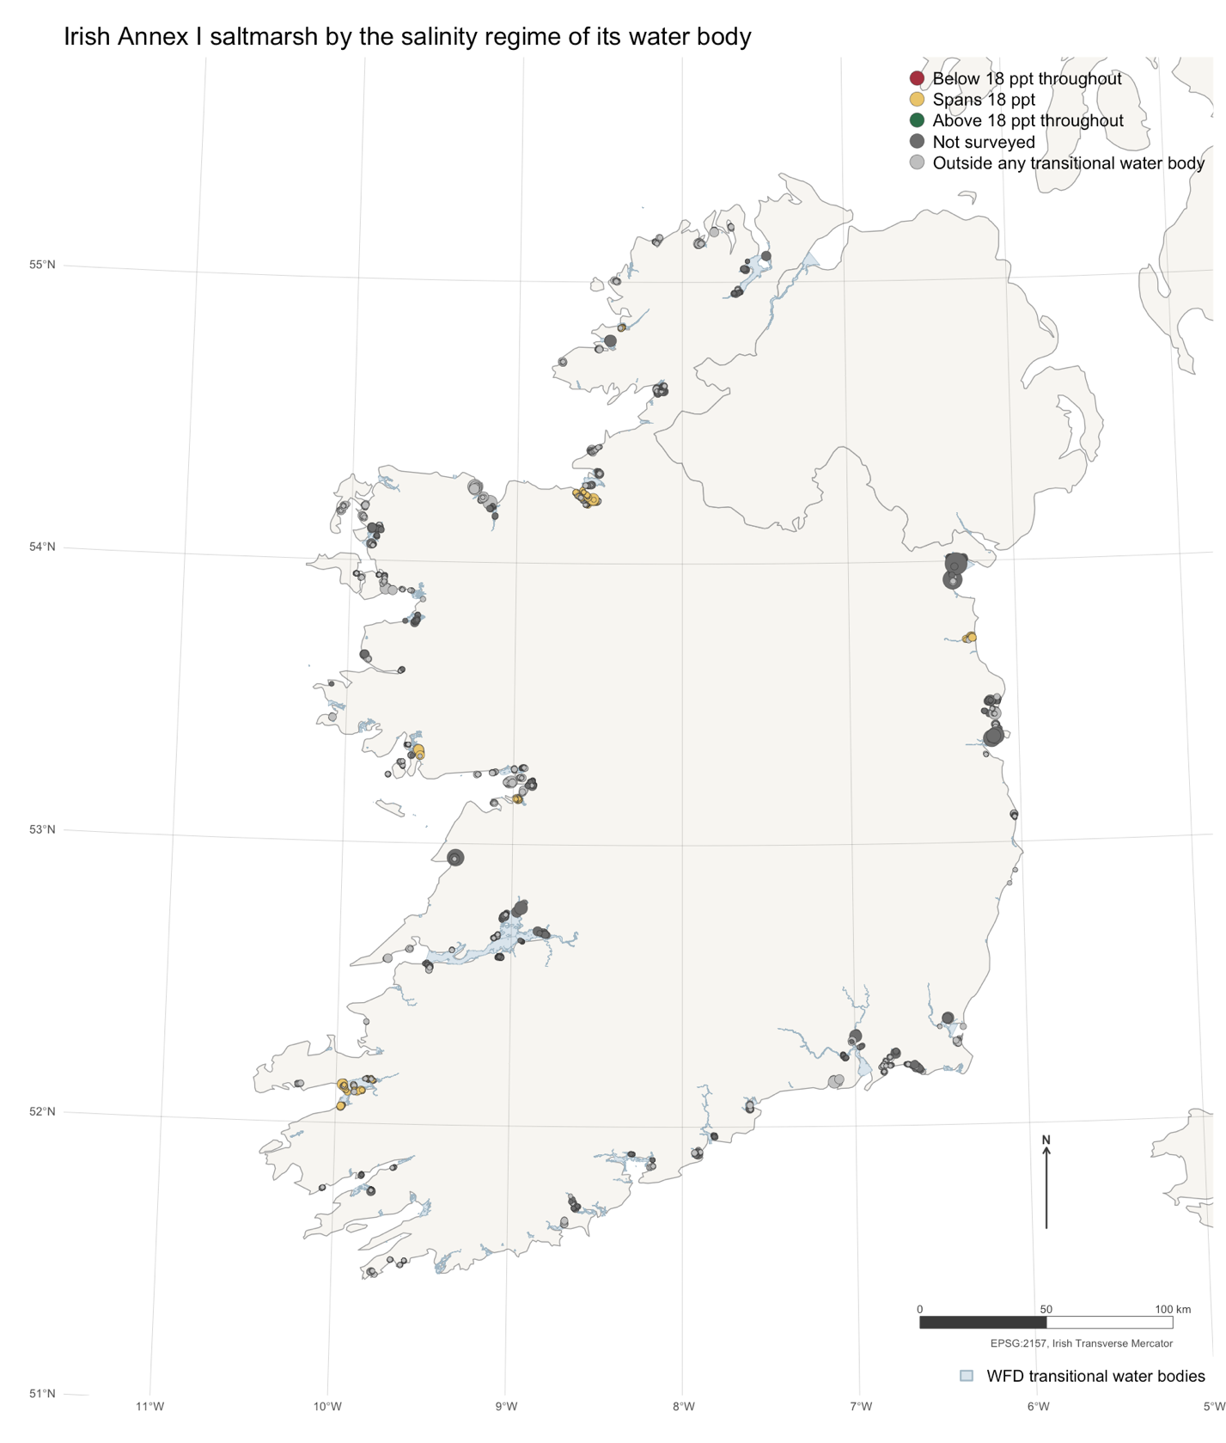
Figure 6: Confirmed Annex I saltmarsh in Ireland, sized by area and coloured by the salinity regime of the transitional water body containing it, over the Water Framework Directive transitional network. No polygon is classified above 18 ppt throughout, and nine tenths cannot be classified at all: dark grey sits in water bodies never surveyed, light grey outside the transitional network entirely.

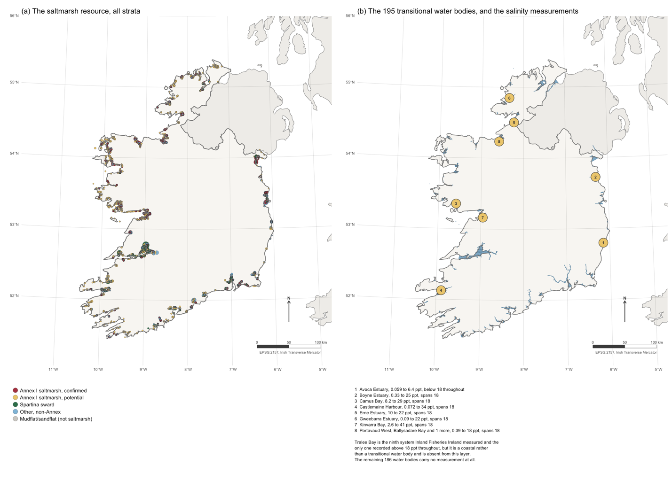
Figure 7: The two Irish coastal datasets behind the salinity gate. (a) The Saltmarsh Monitoring Project resource, all five strata, drawn at polygon centroids and sized by area. (b) The Water Framework Directive transitional water bodies, with the eight Inland Fisheries Ireland systems that carry a 2015 salinity numbered and keyed beneath. Tralee Bay, the ninth and the only one above 18 ppt throughout, is a coastal water body and is not in this layer.
Three limitations bound this. The salinities are water-column measurements at low-tide seine stations rather than marsh porewater, which is generally fresher, and they are single-survey ranges rather than annual means, which is why every classified hectare falls in the “spans” category. And no Irish saltmarsh has been planted or seeded, so none of this area would earn a factor anyway. It bounds the exposure a future Irish pathway would inherit, not a current liability.

3.10 National peatland stocks
The reference-stock logic excludes organic soils by design, and Ireland’s national soils map reproduces that exclusion in the dataset a compiler would open. The figures below are a scoping estimate: they establish the size of the gap, not what should fill it.
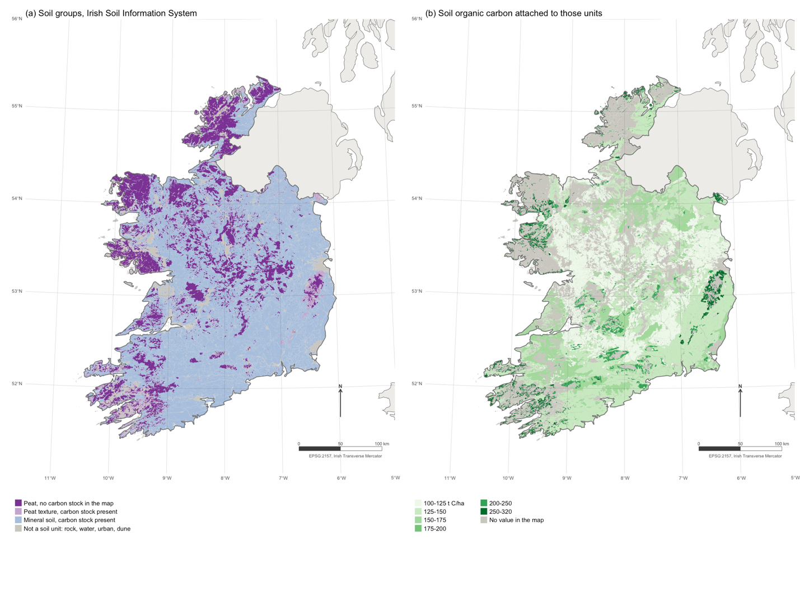
Figure 8: The Irish Soil Information System, 25,143 polygons at 1:250,000. (a) Soil groups, separating peat with no carbon stock in the map from peat that carries one, from mineral soil, from units that are not soils. (b) The soil organic carbon value attached to each unit, with the unattributed area in grey. Northern Ireland lies outside the survey and is shown unfilled.
Two questions follow, and neither can be settled here. The first is whether the absent attribute is recoverable, since the gap falls almost exactly on the estate to which the flux-based method applies. The second must be resolved before any Tier 2 stock is drawn from this map: it reports carbon over the mapped profile depth, while Table 2.3 is defined for 0 to 30 cm, so the two are not comparable until the depth basis is reconciled. We flag it rather than adjust for it.

3.11 National nitrogen factors
Ireland has measured its own direct nitrous oxide factor by fertiliser formulation. Applying those factors to the crossover calculation of §3.5 gives the headline below, on the Table 2.3 default stock for Ireland’s climate zone and dominant soil class, which keeps the figure traceable to an encoded default.
The result points at a research question rather than settling one. If formulation rather than rate is the dominant term, the nitrogen penalty is a policy variable rather than a property of the pathway, and the crossover year becomes something a jurisdiction can move. Two things would have to be established first. The emission factor rises with application rate (Rahman et al., 2021), so a crossover computed at a constant factor is conservative by an unquantified margin. And where a country holds a lower modelled gain than the Tier 1 default, the penalty can exceed it from the first year and no crossover exists.

3.12 Global warming potentials
The metric panel so far has been two horizons of the same pulse-based metric. GWP* is constructed for a different question: how a step change in a sustained short-lived flux, which is what rewetting is, translates into warming.
Table 20: Methane from rewetting under three metrics, t CO2e/ha/yr. GWP* charges the step up for two decades and then charges only the residual of a now-constant flux.
Pathway | GWP-100 | GWP-20 | GWP* years 1-20 | GWP* years 21+
Organic soil rewetting | 3.312 | 9.777 | 8.123 | 0.927
Irish industrial peat extraction | 5.689 | 16.793 | 23.175 | 1.593
GWP* reverses the ranking (Table 20). Under GWP-20 the Irish rewetting methane term is punitive; under GWP* beyond the first two decades the same flux is charged 28% of its GWP-100 value, because a constant emission rate adds no further warming once established.Table 20
This is not a reason to prefer GWP*. It is the reason the panel is reported rather than a winner declared. The three metrics answer three questions: cumulative forcing over a century, over two decades, and additional warming relative to a continuing baseline. A pathway beneficial under the first, harmful under the second and neutral under the third has been shown only to be metric-dependent, which is a statement about the accounting rather than about the peatland.
One caveat belongs with any use of GWP* here. It rewards a step down and penalises a step up relative to a recent baseline, so it credits a jurisdiction for having drained its peatlands and then stopping, and yields nothing for a country with little drained peatland to rewet. That is defensible as physics and awkward as policy, and it is why Allen et al. (Allen et al., 2022) recommend reporting the gases separately.

Case study limitations
The Irish case rests on three independent evidence streams: emission-factor results using published values only, a soils analysis using the national soils map from the EPA’s public web feature service, and an inventory analysis using Ireland’s own reporting tables. The coastal arm is the weakest. The saltmarsh-to-salinity join classifies only a tenth of the resource, because Ireland has measured salinity in nine of its 195 transitional water bodies, and it uses water-column values as a proxy for marsh porewater. Nothing in the Irish case rests on seagrass, for which no measurement exists anywhere on the island.

Discussion
The organic soil results show five of thirteen combinations changing sign between GWP-100 and GWP-20, and the same five failing a 95% probability threshold at GWP-100 alone: Forest Land in the boreal and temperate zones, nutrient-rich temperate Grassland, and temperate peat extraction. That they are the same five is more informative than if they had differed. Metric sensitivity and sampling uncertainty are not independent diagnostics here. They are two ways of detecting the same thing, which is that these five pathways have no margin.
A compiler reporting the GWP-100 point estimate, which is what UNFCCC inventory practice requires, discloses neither.
This bears on a live disagreement. Günther et al. (Günther et al., 2020) conclude that rewetting drained peatland delivers an immediate benefit. Ojanen and Minkkinen (Ojanen & Minkkinen, 2020) put the switchover at forty to a hundred years for forestry-drained sites, Ma et al. (Ma et al., 2024) at 110 years for inland marsh, Launiainen et al. (Launiainen et al., 2025) find boreal peatland forests warming for sixty to eighty years, and Schuster et al. (Schuster et al., 2024) report 525 years for peat systems and conclude that restoration “does not meet the timeframe set by the Paris Agreement”. Nobody has reconciled these. Our results suggest part of the spread is definitional rather than empirical: the same factors yield a benefit or a penalty depending on the horizon at which methane is weighted, and the studies do not share a horizon.
The Irish inventory result is the sharpest form of this. No factor changes between the GWP-100 and GWP-20 lines of Table 18; only the horizon does. A jurisdiction can therefore hold a defensible mitigation claim and a defensible warming claim about the same hectares in the same year, and the guidance offers no basis for preferring either.
Ireland reports at AR5 GWP-100, the metric under which its peatland accounting looks best, and no short-lived-pollutant treatment appears in its land-use reporting. We do not suggest the choice was made to obtain that result: AR5 GWP-100 is the reporting convention, adopted for comparability. The difficulty is that a convention adopted for comparability is doing substantive work, and nothing in the framework surfaces the fact. Two consequences follow. Metric choice should be declared as a methodological parameter with a stated horizon and scope, in the same register as a tier or an activity data source. And where a result changes sign across the panel, the honest report is the panel, not the member of it that supports the intended conclusion.

Drained-rewetted binary constraints
The Tier 1 architecture assigns one factor to “drained” and one to “rewetted” with no transition between them. Evans et al. (Evans et al., 2021) show that every 10 cm reduction in effective water-table depth cuts GWP-100 warming by at least 3 t CO2/ha/yr, which makes the flux a continuous function of a variable the tier structure discretises. And the step assumption ignores a transient: Kalhori et al. (Kalhori et al., 2024) observe methane peaking at 537 kg/ha/yr in year three and falling to 120 by year fourteen, while Vanselow-Algan et al. (Vanselow-Algan et al., 2015) find methane still two to five times the default thirty years on. That disagreement is larger than the difference between the defaults being applied.
The direction of the bias is not neutral. Because the transient is a methane overshoot, a step-change factor understates near-term warming, which is precisely the term the GWP-20 results show to be decisive.
Independent evaluations have moved several of the factors used here. Zhao et al. report the drained cropland factor of Chapter 2, 7.9 t C/ha/yr from 39 sites, overestimating by 31 to 88% at water tables between −0.7 and −0.3 m; the numerically identical coastal factor of Table 4.13 rests on 22 drainage studies of its own, so that critique does not transfer. He and Roulet (He & Roulet, 2023) revise the peat extraction factor down 12% to 2.46 ± 0.25. The tidal marsh accumulation default of 0.91 t C/ha/yr sits two to three times below independent syntheses (Ouyang & Lee, 2014; Wang et al., 2019), although Macreadie et al. (Macreadie et al., 2017) report an Australian value well below it, and the seagrass default rests on six observations. The mangrove default fares better, at 1.62 against 1.386 from 205 observations (Breithaupt & Steinmuller, 2022) and 1.74 in an earlier synthesis (Alongi, 2014).
The direction of these disagreements is not consistent, and that is the more useful observation. Irish tidal marsh accumulates at 0.29 to 0.38 t C/ha/yr (Burke et al., 2022), roughly a third of the same default the global syntheses find two to three times too low. A country applying Tier 1 to Irish saltmarsh would over-credit by a factor of two to three; one applying it to a marsh resembling the global mean would under-credit by as much. A single global value is being asked to serve as a local one, and its error changes sign with region.
The grassland factors are the oldest. F_MG of 1.14 and 1.17 and F_I of 1.11 trace to Ogle et al. (Ogle et al., 2004), a 49-study synthesis, and have passed through two revisions unchanged. Measured rates cluster near 0.28 Mg C/ha/yr (Conant et al., 2017), and Wilcots et al. (Wilcots et al., 2022) found thirteen years of nitrogen addition changing gross primary productivity and respiration while leaving soil carbon stocks unchanged. Ireland’s own Tier 2 factors contest the sign: they average 1.05 against the default 1.14 and fall to 0.85 on gley soils, roughly a fifth of the national soil-association area, where the default books a gain that the national data record as a loss.
The mechanism behind the Irish divergence reported in §3.8 is that the two defaults were built from different populations. Aitova et al. (Aitova et al., 2023) attribute the carbon dioxide pool to intensively managed continental European grassland and the methane pool to deep-drained sites, while Irish conditions are shallow-drained and temperate oceanic. Shallow drainage lowers carbon dioxide loss and raises methane simultaneously, so any single climate-zone default must be wrong on one gas whenever it is right on the other. The Supplement leaves no cell to escape to: deep and shallow drainage are distinguished only within nutrient-rich temperate grassland, and the modal Irish case is nutrient-poor.
A compiler propagating the published Tier 1 intervals would conclude that both factors are uncertain but unbiased. In Ireland both are biased, in opposite directions, and the net effect on a drained-minus-rewetted benefit depends on which gas dominates, which is itself metric-dependent. Bias of this kind is invisible to the uncertainty machinery the guidance provides.

The nutrient fallback penalty
Chapter 2 instructs that where nutrient status is unknown, boreal countries should use the nutrient-poor factor and temperate countries the nutrient-rich one. That rule is written for drained soils. Chapter 3 directs only that a rewetted area be subdivided where the status is known and supplies no fallback, so a compiler working strictly by the book cannot complete the rewetted calculation at all. Extending the drained-side rule is therefore our own assumption. Ireland shows what it costs.
Ireland is temperate, so the rule assigns nutrient-rich factors of +0.5 t CO2-C/ha/yr and 216 kg CH4-C/ha/yr. Its peatland estate is overwhelmingly ombrotrophic, roughly 1.4 Mha of bog against some 20,000 ha of fen, for which the appropriate nutrient-poor factors are −0.23 and 92. The fallback converts a modelled sink into a modelled source by assumption alone, for a country whose peatlands are almost entirely of the class the rule declines to assume, and it errs in the direction that penalises the intervention the guidance exists to encourage.
The Irish case also shows how thin the evidence beneath the nutrient split can be. Every Irish nutrient-rich datum comes from industrially cutaway raised bog, where extraction exposed richer basal peat, or from a single deep-drained grassland site. None comes from a fen. The class that governs the sign of the result is populated by sites that do not belong to it.

The salinity gate
Table 4.14 switches methane off entirely above 18 ppt. The threshold traces to Poffenbarger et al. (Poffenbarger et al., 2011) and its location is broadly supported: Arias-Ortiz et al. place breakpoints at 21 ± 2 psu in porewater or 15 ± 3 psu in surface water. Its form is not. The relationship is quantile suppression rather than a step to zero, salinity correlates with methane in salt marsh but not in seagrass or mangrove (Al‐Haj & Fulweiler, 2020), and plant species alone explains 62% of tidal marsh methane variance. Since the gate reverses the sign of the coastal pathway, a binary switch on a weakly predictive covariate is carrying more accounting weight than the evidence supports.
For inventory compilers the recommendation is narrow and implementable: report the offsetting methane and nitrous oxide fluxes and the applicable duration rule alongside any claimed soil carbon gain, and state the metric and horizon. None of this requires new data, only that terms already computed under the guidance be reported together rather than in separate chapters.
For crediting the problem is harder, because the Wetlands Supplement supplies a flux methodology and no baseline-and-credit architecture. Wetland Drainage and Rewetting under the Kyoto Protocol Supplement has no project boundary and no baseline; its counterfactual is a fixed base year under net-net accounting. A project standard that imports the Tier 1 factors without importing a counterfactual will credit the absolute gain, which the inland wetland mineral results show can be smaller than its own methane offset. This matters at the scale the sector now operates: soil carbon protocols may overestimate stocks by up to 2.5 times (Dupla et al., 2024), Australian issuance in 2023 implied 2 to 8 t C/ha/yr against a literature range of 0.1 to 1.2 (Mitchell et al., 2024), and blue carbon delivery stands at roughly 2% of estimated potential across 81 projects (Farahmand et al., 2025).

The EU’s response to Tier 1
On 9 July 2026 the European Commission adopted the certification methodologies for carbon farming under the Union’s carbon removals framework (European Commission, 2026). One of the three covers rewetting and restoration of peatlands and other organic soils, making it the first binding instrument to specify how a countable soil carbon gain becomes a creditable one. Four features bear on the arguments above, and they run in the same direction.
First, Tier 1 defaults are excluded from the pool this paper is about. The Annex permits only models and proxies for soil organic carbon in organic soils, confining default emission factors to nitrous oxide from managed agricultural soils, liming and urea, and fuel combustion. The soil flux the intervention is actually about cannot be taken from a default table at all.
Second, methane must be quantified rather than assumed. Carbon dioxide, methane and nitrous oxide are all assigned to the organic soil pool. A proxy model must rest on a meta-analysis including at least carbon dioxide and methane, must relate site variables such as water-table depth or vegetation type to fluxes by statistical regression, and must be validated on year-round measurements at no fewer than 100 sites. Off-site fluvial losses are mandatory wherever carbon dioxide from organic soils is reported.
Third, the methane overshoot is priced. For the first five years, either the absence of a methane peak must be made plausible from monitored vegetation and water table, or ten tonnes of carbon dioxide equivalent per hectare are deducted each year. That is a regulator converting the transient this paper discusses into a default charge, and its magnitude is instructive: it exceeds the entire GWP-100 benefit of the five weakest rows in our ledger.
Fourth, the crediting horizon is capped by the substrate rather than by convention. The activity period runs a minimum of ten years and a maximum of thirty, or the time to exhaust the peat in the absence of the activity, whichever is shorter, with depletion set at 1.0 cm per year on ombrotrophic bogs and 1.5 cm on fens. This is the first duration rule in the corpus derived from a physical quantity rather than assumed.
Two provisions sit less comfortably. The uncertainty deduction is set at eight per cent or the estimated uncertainty, whichever is higher, while the recitals describe the same floor as at least ten per cent, and the two are not reconciled. And peatland rewetting is exempted from any liability mechanism or buffer pool on the reasoning that avoided emissions are irreversible. Our results complicate that: a rewetted site can revert to a source through drainage failure or drought, and the near-natural reference condition is itself a net source once methane is counted.
The instrument now governing this in Europe has reached the same conclusion this analysis reaches from the factor tables. A Tier 1 default is adequate for reporting a national aggregate and inadequate for crediting a hectare, and the gases that decide whether an intervention helps cannot be left to a default that assumes them away.

Tier 1 Limitations
Four limitations bound the analysis. Uncertainty is propagated for the organic soil benefit alone, so the coastal, inland mineral and grassland results report a sign without a probability attached.
Within that Monte Carlo the intervals are narrower than the true uncertainty. Only the carbon dioxide factor on each side and the methane factor on the rewetted side carry published bounds; land methane, ditch methane, the ditch fraction and nitrous oxide on the drained side enter at their defaults, so the reported probabilities of benefit are upper bounds on confidence.
The reference stock analysis encodes the Tropical, Warm temperate and Cool temperate rows of Table 2.3 and not the Polar and Boreal rows, so the mean-versus-median bias is established across eight of the ten published climate zones. The organic soil benefit is unaffected, taking its factors from the Wetlands Supplement.
Extending the Chapter 2 nutrient fallback to the rewetted side is our own assumption, because Chapter 3 supplies none and the calculation cannot otherwise be completed. Every rewetted result for which nutrient status is unknown inherits that choice, and the Irish case shows it is not a small one.

Conclusions
A countable carbon gain is not a climate benefit, and the guidance that makes the gain countable supplies no way to tell the two apart. Assembling the Tier 1 and Tier 2 gain pathways on a single greenhouse-gas-weighted axis shows the gap is not marginal. Rewetting organic soils is beneficial at the published point estimates in every combination at GWP-100 but harmful in five of thirteen at GWP-20, and the probability of benefit falls below 0.95 in the same five at GWP-100 alone. Inland wetland mineral soil rewetting books a positive stock change that its own methane factor exceeds in all nine climate regions for twenty years, with no counterfactual in Chapter 5 to offset against. A restored tidal marsh below 18 ppt is a net source in absolute terms while remaining a benefit of some 27 t CO2e/ha/yr against the drained state. And fertilised improved grassland crosses into net source under the model’s own assumptions, because a twenty-year gain is set against a perpetual penalty. In Ireland’s reported inventory the same pathway is worth about seven t CO2e/ha/yr at GWP-100 and costs nearly three at GWP-20, with no factor changing between the two lines.
The common structure is that each countable gain is awarded in one chapter and its offset governed by another, with no arithmetic anywhere that brings them together. The remedy requires no new science. It requires that the offsetting fluxes, the duration rule, and the metric with its horizon be reported alongside the gain, and that any pathway whose sign moves across a defensible metric panel be reported as metric-dependent rather than as a benefit.
That remedy is no longer hypothetical. In adopting its carbon farming certification methodologies in July 2026, the European Union excluded default emission factors from the organic soil pool, required methane to be quantified rather than assumed, priced the post-rewetting methane transient, and capped the crediting horizon at the physical exhaustion of the peat (European Commission, 2026). The distinction it draws is the one this paper argues for: a Tier 1 default is a reasonable instrument for reporting a national aggregate and an inadequate one for crediting a hectare, because reporting tolerates errors that cancel across a country while crediting does not.

Declarations

Ethics approval and consent to participate
Not applicable. This study analyses published emission factors and public datasets and involves no human participants, human data or animals.

Consent for publication
Not applicable.

Data availability statement
All emission factors and reference stocks used here are transcribed from the published IPCC guidance and are encoded in the manuscript source, so the analysis reproduces from the document itself. The four external datasets, their provenance and the derivation scripts that process them are described in §2.7. The manuscript source, the derivation scripts, the derived tables and the figure code are archived at https://github.com/seamusrobertmurphy/ipcc-carbon-gains. The Irish Soil Information System national soils map, the NPWS Saltmarsh Monitoring Project layer and the EPA Water Framework Directive water bodies are third-party datasets available from their respective public services under their own terms.

Competing interests
The author declares no competing interests.

Funding
The work received no specific funding.

Author contributions
Stated in CRediT taxonomy terms. Seamus Murphy: conceptualization; data curation; formal analysis; investigation; methodology; software; validation; visualisation; writing, original draft; writing, review and editing. As sole author he read and approved the final manuscript.

Use of generative artificial intelligence
Every emission factor, reference stock and confidence bound was verified by the author against the published IPCC documents, and all code was reviewed and executed by the author. No generative tool was used to create, alter or manipulate research data or results. The author is responsible for the accuracy of all content.

Acknowledgements
The analysis rests entirely on published IPCC guidance and on public datasets from the Irish Soil Information System (Teagasc and the Environmental Protection Agency), the National Parks and Wildlife Service Saltmarsh Monitoring Project, Inland Fisheries Ireland and the Environmental Protection Agency Water Framework Directive programme, whose maintainers are thanked for making them openly available.

References
Aitova, E., Morley, T., Wilson, D. & Renou-Wilson, F. 2023. A review of greenhouse gas emissions and removals from irish peatlands. Mires and Peat, 29, 04.
Al‐Haj, A.N. & Fulweiler, R.W. 2020. A synthesis of methane emissions from shallow vegetated coastal ecosystems. Global Change Biology, 26, 2988–3005.
Allen, M.R., Peters, G.P., Shine, K.P., Azar, C., Balcombe, P., Boucher, O., Cain, M., Ciais, P., Collins, W., Forster, P.M., Frame, D.J., Friedlingstein, P., Fyson, C., Gasser, T., Hare, B., Jenkins, S., Hamburg, S.P., Johansson, D.J.A., Lynch, J., Macey, A., Morfeldt, J., Nauels, A., Ocko, I., Oppenheimer, M., Pacala, S.W., Pierrehumbert, R., Rogelj, J., Schaeffer, M., Schleussner, C.F., Shindell, D., Skeie, R.B., Smith, S.M. & Tanaka, K. 2022. Indicate separate contributions of long-lived and short-lived greenhouse gases in emission targets. npj Climate and Atmospheric Science, 5.
Alongi, D.M. 2014. Carbon cycling and storage in mangrove forests. Annual Review of Marine Science, 6, 195–219.
Batjes, N.H. 2010. A global framework of soil organic carbon stocks under native vegetation for use with the simple assessment option of the carbon benefits project system (ver. 1.0). ISRIC World Soil Information, Wageningen, the Netherlands.
Batjes, N.H. 2011. Soil organic carbon stocks under native vegetation – revised estimates for use with the simple assessment option of the carbon benefits project system. Agriculture, Ecosystems & Environment, 142, 365–373.
Breithaupt, J.L. & Steinmuller, H.E. 2022. Refining the global estimate of mangrove carbon burial rates using sedimentary and geomorphic settings. Geophysical Research Letters, 49.
Burke, S.A., Manahan, J., Eichelmann, E. & Cott, G.M. 2022. Dublin’s saltmarshes contain climate-relevant carbon pools. Frontiers in Marine Science, 9, 976457.
Conant, R.T., Cerri, C.E.P., Osborne, B.B. & Paustian, K. 2017. Grassland management impacts on soil carbon stocks: A new synthesis. Ecological Applications, 27, 662–668.
Dupla, X., Bonvin, E., Deluz, C., Lugassy, L., Verrecchia, E., Baveye, P.C., Grand, S. & Boivin, P. 2024. Are soil carbon credits empty promises? Shortcomings of current soil carbon quantification methodologies and improvement avenues. Soil Use and Management, 40.
European Commission. 2026. Commission delegated regulation supplementing regulation (EU) 2024/3012 of the european parliament and of the council by establishing the certification methodologies for carbon farming activities.
Evans, C.D., Peacock, M., Baird, A.J., Artz, R.R.E., Burden, A., Callaghan, N., Chapman, P.J., Cooper, H.M., Coyle, M., Craig, E., Cumming, A., Dixon, S., Gauci, V., Grayson, R.P., Helfter, C., Heppell, C.M., Holden, J., Jones, D.L., Kaduk, J., Levy, P., Matthews, R., McNamara, N.P., Misselbrook, T., Oakley, S., Page, S.E., Rayment, M., Ridley, L.M., Stanley, K.M., Williamson, J.L., Worrall, F. & Morrison, R. 2021. Overriding water table control on managed peatland greenhouse gas emissions. Nature, 593, 548–552.
Farahmand, S., Hilmi, N. & Duarte, C.M. 2025. The rise and flows of blue carbon credits advance global climate and biodiversity goals. npj Ocean Sustainability, 4.
Forster, P., Storelvmo, T., Armour, K., Collins, W., Dufresne, J.-L., Frame, D., Lunt, D.J., Mauritsen, T., Palmer, M.D., Watanabe, M., Wild, M. & Zhang, H. 2021. The earth’s energy budget, climate feedbacks and climate sensitivity. In: Climate change 2021: The physical science basis. Contribution of working group i to the sixth assessment report of the intergovernmental panel on climate change, pp. 923–1054. Cambridge University Press, Cambridge, United Kingdom; New York, NY, USA.
Günther, A., Barthelmes, A., Huth, V., Joosten, H., Jurasinski, G., Koebsch, F. & Couwenberg, J. 2020. Prompt rewetting of drained peatlands reduces climate warming despite methane emissions. Nature Communications, 11.
He, H. & Roulet, N.T. 2023. Improved estimates of carbon dioxide emissions from drained peatlands support a reduction in emission factor. Communications Earth & Environment, 4.
IPCC. 2014. 2013 supplement to the 2006 IPCC guidelines for national greenhouse gas inventories: wetlands. Hiraishi, T., Krug, T., Tanabe, K., Srivastava, N., Baasansuren, J., Fukuda, M.; Troxler, T.G. (eds). IPCC, Switzerland.
IPCC. 2019. 2019 refinement to the 2006 IPCC guidelines for national greenhouse gas inventories. Calvo Buendia, E., Tanabe, K., Kranjc, A., Baasansuren, J., Fukuda, M., Ngarize, S., Osako, A., Pyrozhenko, Y., Shermanau, P.; Federici, S. (eds). IPCC, Switzerland.
Kalhori, A., Wille, C., Gottschalk, P., Li, Z., Hashemi, J., Kemper, K. & Sachs, T. 2024. Temporally dynamic carbon dioxide and methane emission factors for rewetted peatlands. Communications Earth & Environment, 5.
Launiainen, S., Ahtikoski, A., Rinne, J., Ojanen, P. & Hökkä, H. 2025. Rewetting drained boreal peatland forests does not mitigate climate warming in the twenty-first century. Ambio, 54, 2107–2117.
Li, C., Frolking, S. & Butterbach-Bahl, K. 2005. Carbon sequestration in arable soils is likely to increase nitrous oxide emissions, offsetting reductions in climate radiative forcing. Climatic Change, 72, 321–338.
Lugato, E., Leip, A. & Jones, A. 2018. Mitigation potential of soil carbon management overestimated by neglecting N2O emissions. Nature Climate Change, 8, 219–223.
Macreadie, P.I., Ollivier, Q.R., Kelleway, J.J., Serrano, O., Carnell, P.E., Ewers Lewis, C.J., Atwood, T.B., Sanderman, J., Baldock, J., Connolly, R.M., Duarte, C.M., Lavery, P.S., Steven, A. & Lovelock, C.E. 2017. Carbon sequestration by australian tidal marshes. Scientific Reports, 7.
Ma, S., Creed, I.F. & Badiou, P. 2024. New perspectives on temperate inland wetlands as natural climate solutions under different CO2-equivalent metrics. npj Climate and Atmospheric Science, 7.
Mitchell, E., Takeda, N., Grace, L., Grace, P., Day, K., Ahmadi, S., Badgery, W., Cowie, A., Simmons, A., Eckard, R., Harrison, M.T., Parton, W., Wilson, B., Orgill, S., Viscarra Rossel, R.A., Pannell, D., Stanley, P., Deane, F. & Rowlings, D. 2024. Making soil carbon credits work for climate change mitigation. Carbon Management, 15.
Ogle, S.M., Conant, R.T. & Paustian, K. 2004. Deriving grassland management factors for a carbon accounting method developed by the intergovernmental panel on climate change. Environmental Management, 33.
Ojanen, P. & Minkkinen, K. 2020. Rewetting offers rapid climate benefits for tropical and agricultural peatlands but not for forestry‐drained peatlands. Global Biogeochemical Cycles, 34.
Ouyang, X. & Lee, S.Y. 2014. Updated estimates of carbon accumulation rates in coastal marsh sediments. Biogeosciences, 11, 5057–5071.
Poffenbarger, H.J., Needelman, B.A. & Megonigal, J.P. 2011. Salinity influence on methane emissions from tidal marshes. Wetlands, 31, 831–842.
Rahman, N., Richards, K.G., Harty, M.A., Watson, C.J., Carolan, R., Krol, D., Lanigan, G.J. & Forrestal, P.J. 2021. Differing effects of increasing calcium ammonium nitrate, urea and urea + NBPT fertiliser rates on nitrous oxide emission factors at six temperate grassland sites in ireland. Agriculture, Ecosystems & Environment, 313, 107382.
Schuster, L., Taillardat, P., Macreadie, P.I. & Malerba, M.E. 2024. Freshwater wetland restoration and conservation are long-term natural climate solutions. Science of The Total Environment, 922, 171218.
Vanselow-Algan, M., Schmidt, S.R., Greven, M., Fiencke, C., Kutzbach, L. & Pfeiffer, E.-M. 2015. High methane emissions dominated annual greenhouse gas balances 30 years after bog rewetting. Biogeosciences, 12, 4361–4371.
Wang, F., Lu, X., Sanders, C.J. & Tang, J. 2019. Tidal wetland resilience to sea level rise increases their carbon sequestration capacity in united states. Nature Communications, 10.
Wilcots, M.E., Schroeder, K.M., DeLancey, L.C., Kjaer, S.J., Hobbie, S.E., Seabloom, E.W. & Borer, E.T. 2022. Realistic rates of nitrogen addition increase carbon flux rates but do not change soil carbon stocks in a temperate grassland. Global Change Biology, 28, 4819–4831.
Wilson, D., Blain, D., Couwenberg, J., Evans, C.D., Murdiyarso, D., Page, S.E., Renou-Wilson, F., Rieley, J.O., Sirin, A., Strack, M. & Tuittila, E.-S. 2016. Greenhouse gas emission factors associated with rewetting of organic soils. Mires and Peat, 17, 04.
Zhang, X., Ots, M., Johnston, E., Brown, K., Doar, N. & Lynch, J. 2025. Peatland restoration is anticipated to provide climate change mitigation over all time-scales: A UK case-study. Environmental Research Communications, 7, 115011.

